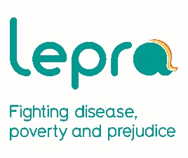
Individual stories of change from Lepra’s Koraput Referral Centre

Jhali’s story – how health education can change lives
Jhali Paraja is 18 years old and lives with her father in Bhagra village of Koraput District. They make a meagre living by cultivating their 1 acre of land.
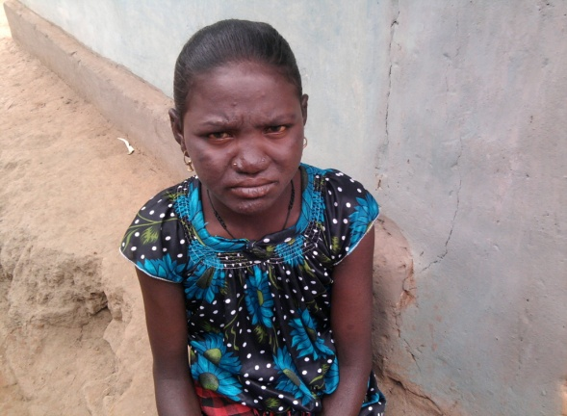
Jhali first noticed unusual symptoms in February 2014; her face has become oily and shiny, and both her earlobes thickened within 6 months. She was unaware of leprosy and visited a local traditional healer to seek treatment. Her father spent 500 rupees (around £5) on black magic, for them a large sum for an ineffective treatment. Slowly her condition became worse; she developed nodules on her hands and feet and lived with fevers and joint pain. She again visited a traditional healer who gave her injections inappropriate for her condition at a cost of 500 rupees.
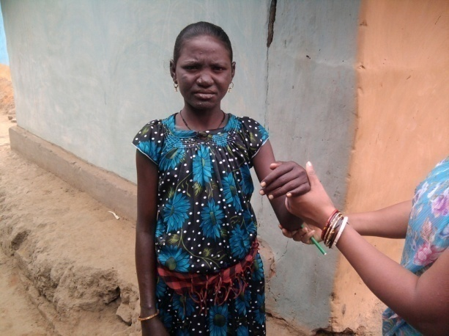
In September 2014 staff from Koraput Leprosy Centre organised a health education campaign in her village. Jhali and her father were present and for the first time became aware of leprosy and how to spot its symptoms. The event helped them to realise that Jhali’s symptoms may be due to leprosy and the next day they approached a community health worker. The community health worker had been trained by Lepra and was able to refer Jhali to Lepra’s Koraput Leprosy Centre to confirm her diagnosis and start treatment. Jhali was diagnosed with leprosy and reactions, painful reactions to the leprosy bacteria. She was provided with appropriate treatment and admitted to the leprosy centre whilst under steroid treatment for the reactions. When the reactions subsided she returned home to complete her course of multi-drug therapy. At the end of 2015 she was declared as leprosy free. Due to her treatment for reactions she has recovered fully and been left with no lasting effects from leprosy. Jhali can now look forward to a leprosy free future.

Basanti’s story
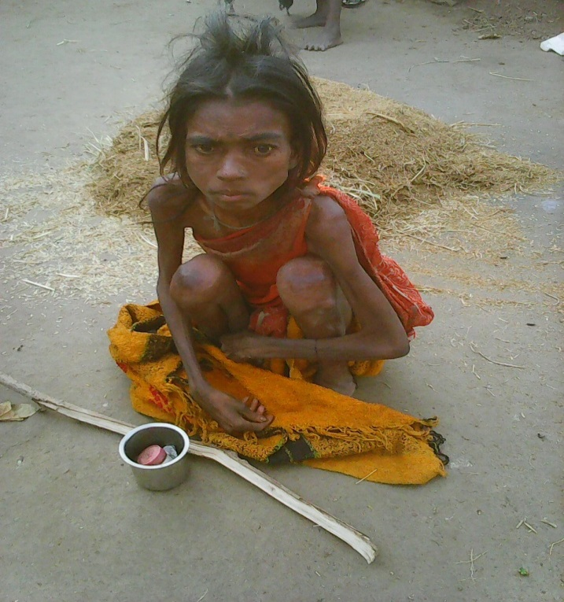
Basanti Paraja lives in Dubuli village of Koraput district; a small tribal community of 55 households in a remote location. Basanti is a 35 year old widow and mother of three children. The family is landless and survives on wages from daily labour.
In January 2014, Basanti noticed she had swollen glands but she ignored the symptoms because she was unaware of what her condition could be. Then her body weight started gradually reducing. She visited a local traditional healer and started taking herbal medicines but they had no effect and she became more unwell. Eventually a Lepra trained DOTS provider (a person trained in supporting and administering TB treatment) from Basanti’s village came into contact with her and suspected that she might have TB. She was taken to Lepra’s Koraput TB centre at the end of 2014. Koraput’s Medical Officer examined her and performed tests which confirmed TB. She was just 23 kgs in weight and very weak. She started treatment for TB and was also advised and supported in eating nutritious foods to aid her recovery. Staff from Koraput TB centre regularly visited her to monitor her progress and ensure that she stuck to her treatment. Her health gradually improved during the long treatment which was supervised by her local Lepra trained DOTS provider. She finally completed her intensive treatment at the end of 2015. Her weight had increased to 30kgs and she was confirmed as cured of TB. Basanti is now better and able to care for her young family.

